Yelp Business Intelligence & Customer Analytics
Business Report

DATA OVERVIEW

. This dataset is a subset of Yelp and has information about businesses across 8 metropolitan areas in the USA and Canada.

. The original data is shared by Yelp as JSON files.

. The five JSON files are business, review, user, tip and checking.

. The JSON files are stored in the database for easy retrieval of data.

ANALYSIS AND FINDINGS
. Out of 150k businesses, 35k are restaurants business and are open.
. Table showing distribution of business success metrics (review count and
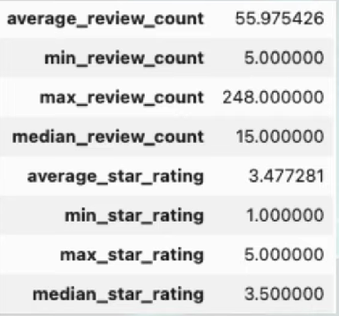
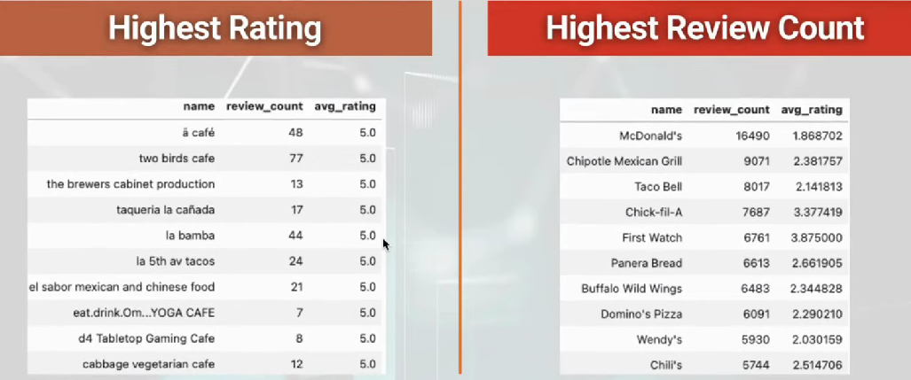
· Higher ratings do no guarantee a higher review count, or vice versa.
. Success of Restaurants is not solely determined by ratings or review counts.
. Review count reflects user engagement but not necessarily overall customer satisfaction or business performance.
· Data shows a general increase in average review, check-in, and tip
Do restaurants with higher engagement tend to have
higher ratings?
· Restaurants rated 4 stars exhibit the highest engagement and shows a downward trend for rating above 4.
· The drop in engagement at 5.0 stars might suggest either a saturation pointspace

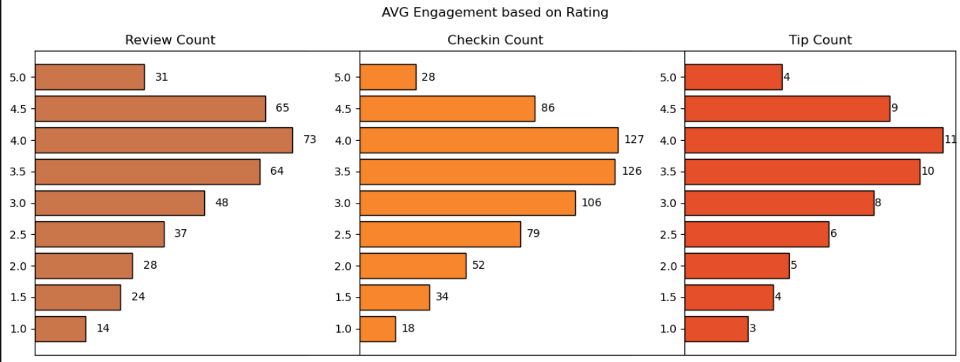, as increases in one type of engagement are likely to drive increases in others, enhancing overall visibility and interaction with customers.
Is there a correlation between the number of reviews,
tips, and check-ins for a business?
. These correlations suggest that user engagement across different platforms (reviews, tips, and check-ins) is interlinked; higher activity in one area tends to be associated with higher activity in others.
. Businesses should focus on strategies that
boost all types of user engagement

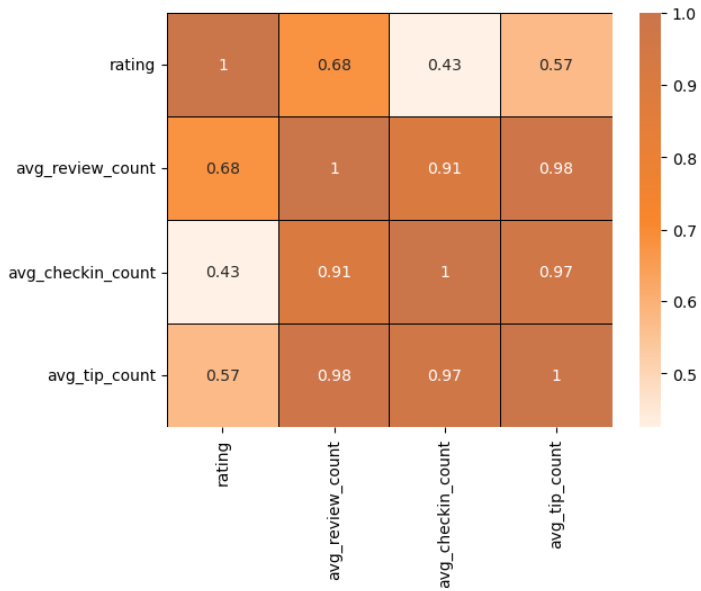
Is there a difference in the user engagement between high- rated and low-rated businesses?

· Data indicates a clear correlation between higher ratings and increased user engagement across reviews, tips, and check-ins.
. This pattern underscores the importance of maintaining high service and quality standards, as these appear to drive more reviews, check-ins, and tips, which are critical metrics of customer engagement and satisfaction.

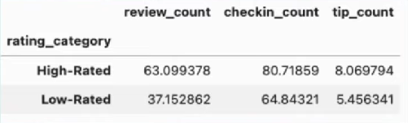
How do the success metrics of restaurants vary across different states and cities?
. Philadelphia emerges as the top city with the highest success score,
indicating a combination of high ratings and active user engagement.
Philadelphia, Indianapolis, and Tucson rank among the top cities with significant success scores, suggesting thriving restaurant scenes in these areas.

· Following Tampa,United States ,Los Angeles ,Phoenix ,México ,La Habana'

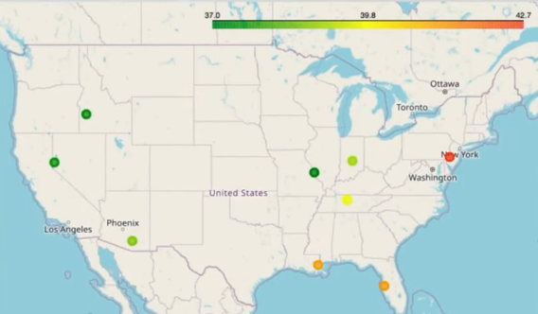
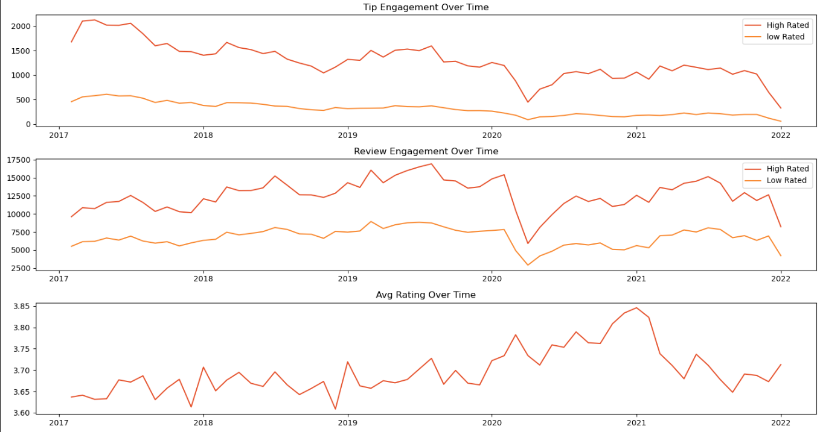

- Successful and possibly rated restaurants time,customer satisfaction, businesses, particularly those with higher ratings (above 3.5), exhibit consistent increasing user engagement over time.
- High maintain a steady or growing level of user engagement over reflecting interest ongoing and

BUSIEST HOURS
V The busiest hours for restaurants, based on use engagement, span from 4 pm to 1 am.
Knowing the peak hours allows businesses to optimize their staffing levels and resource allocation during these times to ensure efficient operations and quality service delivery
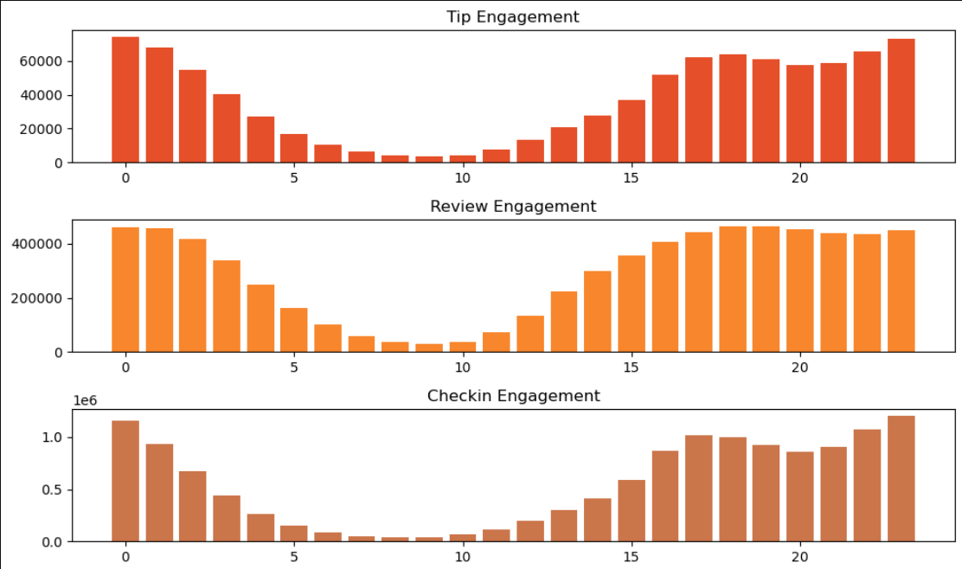
The concentration of user engagement during the evening and night hours suggests a higher demand for dining out during these times, potentially driven by factors such as work schedules, social gatherings, and leisure activities.
SENTIMENT ANALYSIS
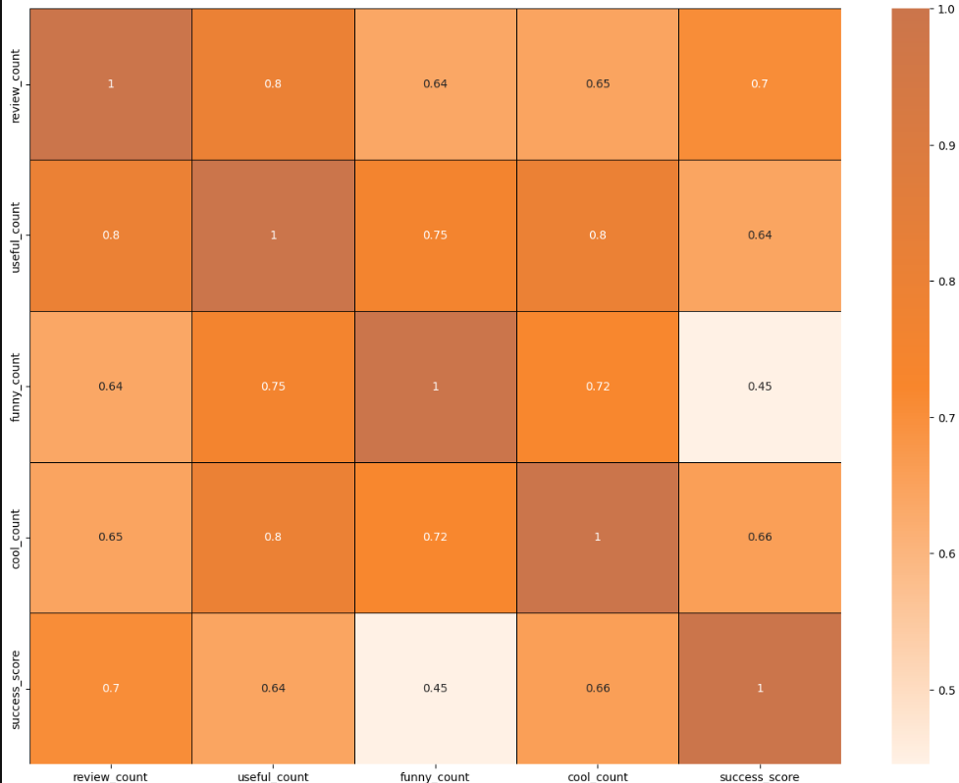
- “useful, " "funny, " and "cool" are attributes associated with user reviews. They represent the feedback provided by users about the usefulness, humor, or coolness of a particular review.
- Higher counts of useful, funny, and cool reviews suggest greater user engagement and satisfaction, which are key factors contributing to a restaurant's success

RECOMMENDATIONS
- Utilizing insights from the analysis of various metrics such as user engagement, sentiment of reviews, peak hours, and the impact of elite users, businesses can make informed decisions to drive success.
- Understanding customer preferences, behavior, and satisfaction levels is paramount. Businesses should focus on delivering exceptional experiences to meet customer expectations.
- By leveraging data on peak hours and user engagement, businesses can optimize staffing levels, resource allocation, and operating hours to ensure efficiency and quality service delivery during high-demand periods.
- Positive reviews from elite users and high user engagement can boost a business's online visibility and reputation. Maintaining active engagement with customers and responding promptly to feedback is crucial for building credibility and attracting new customers.
- Collaborating with elite users and leveraging their influence can amplify promotional efforts, increase brand awareness, and drive customer acquisition. Building strong relationships with key stakeholders, including loyal customers, can further strengthen a business's position in the market.
- Businesses can adjust their operating hours or introduce special promotions to capitalize on the increased demand during peak hours.
- Less successful businesses may need to focus on strategies to enhance user engagement over time, such as improving service quality, responding to customer feedback.
- Cities with high success scores presents opportunities for restaurant chains to expand or invest further.

